## Darshan Nikam Date: 11/03/2024

### **VPC Peering connection**

A VPC peering connection is a networking connection between two VPCs that enables you to route traffic between them using private IPv4 addresses or IPv6 addresses. Instances in either VPC can communicate with each other as if they are within the same network.

You can create a VPC peering connection between your own VPCs, or with a VPC in another AWS account. The VPCs can be in different Regions or the same Region.

Types of VPC Peering

|  |  |
| --- | --- |
| Inter-region VPC Peering   * Connects VPCs in different cloud regions. * Enables global communication between resources across regions. * Helps in building distributed applications while maintaining network isolation. | Cross-account VPC Peering   * Connects VPCs owned by different AWS accounts. * Facilitates collaboration or resource sharing between different accounts. * Requires explicit authorization from both AWS accounts involved. * Ensures network segregation and security between peered VPCs. |

To Create a VPC Peering Connection follow the following steps.

1. Create two VPCs in two different Regions. Ensure that the CDIR block of both VPC does not overlap.

First VPC in the Paris Region

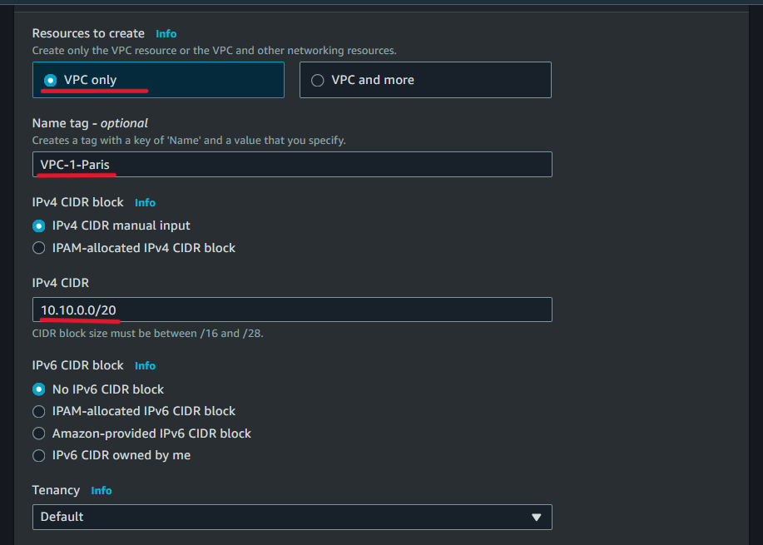

Second VPC in the London Region

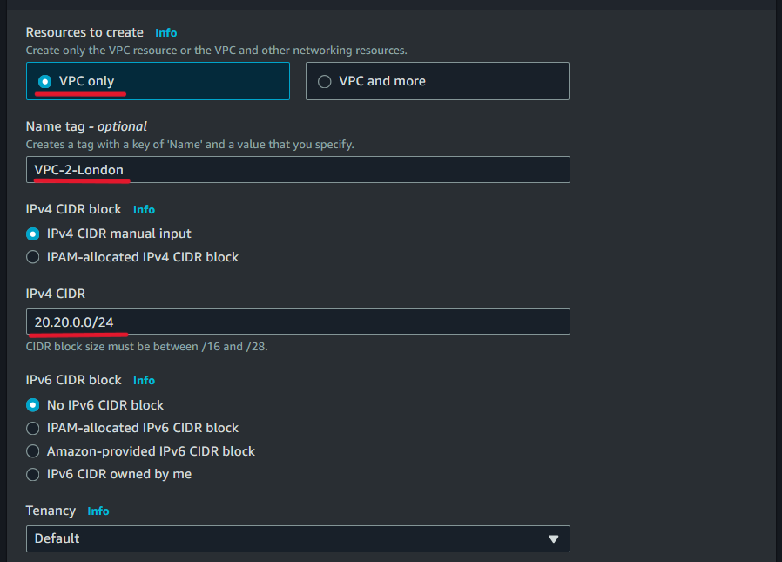

1. After Creating VPC we need to create subnets for both VPC.

* In Paris Region VPC, we will create 1 public subnet and 1 private subnet.

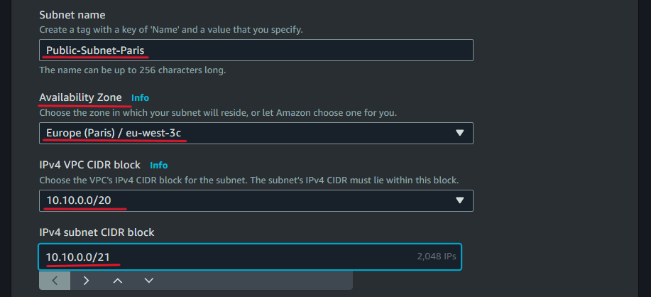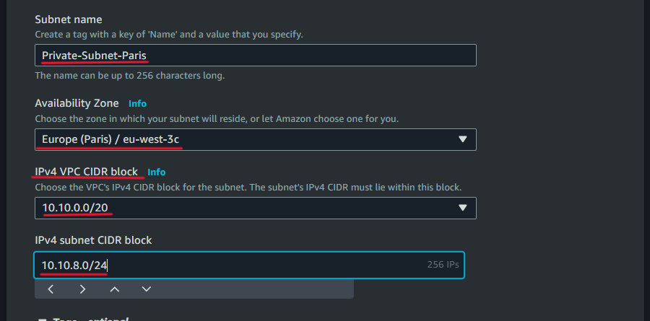

* After creating a subnet, go to the public subnet setting, enable Auto-assign Public IP (to make public this subnet), and save the changes.

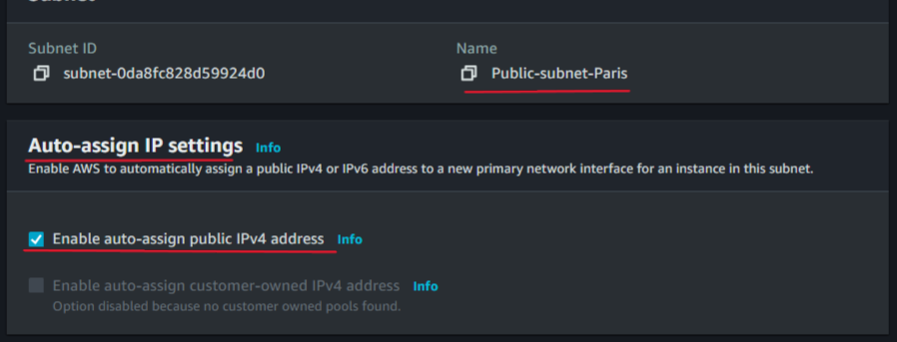

* Now Create a Subnet in the London Region VPC. Here we create only a Private subnet.

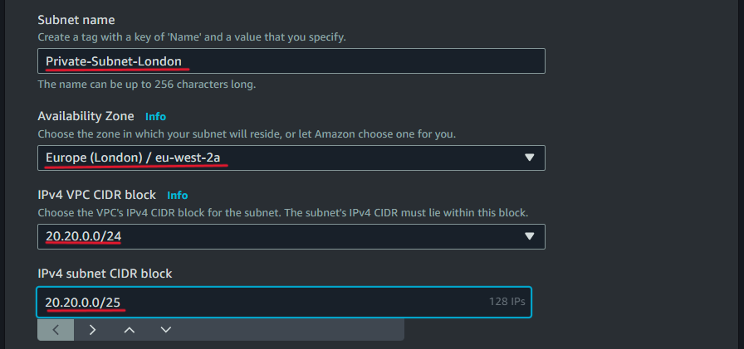

1. Now We Need to Create an Internet Gateway for VPC in the Paris Region.

* Create an Internet Gateway and save.

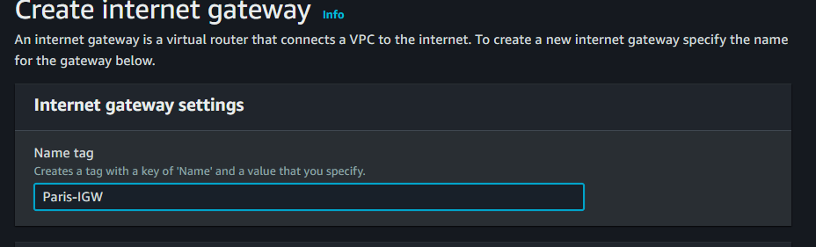

* After Creating IGW attach it to our custom VPC in Paris Region.

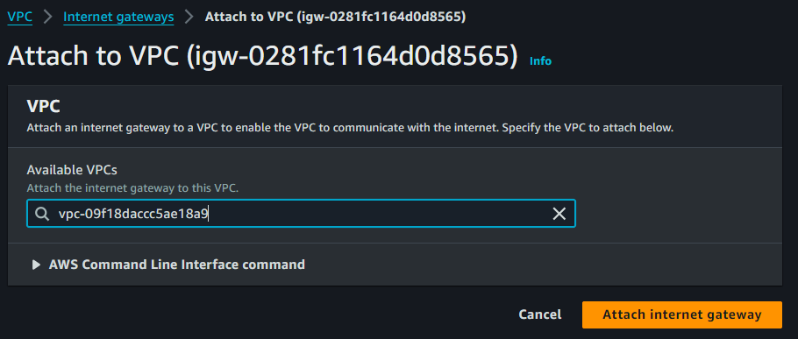

1. When we created the VPC, the route table was created by default.

* Edit the default Route Table of the Paris region and add the route setting up a target to the Internet gateway.

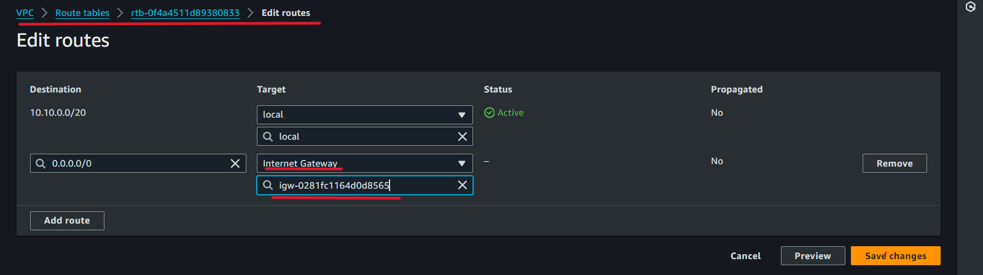

1. Now we will create a peering Request from our VPC in the Paris region for VPC in the London region.

* In VPC Dashboard select Peering connection Option, and click on the Create Peering connection button.

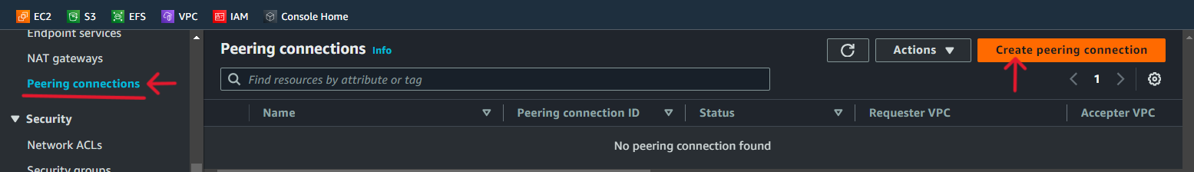

* Name the Peering connection, and select our Custom VPC ID.

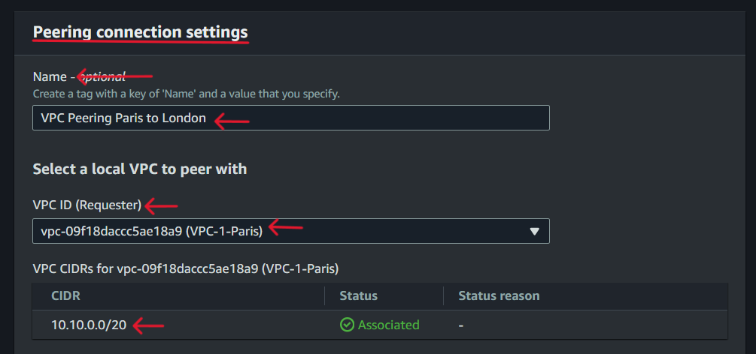

* Now Select the London region where we created our 2nd VPC, copy the London region’s Custom VPC ID, then paste it here in the VPC ID accepter box, and click the ok Create Peering connection button.

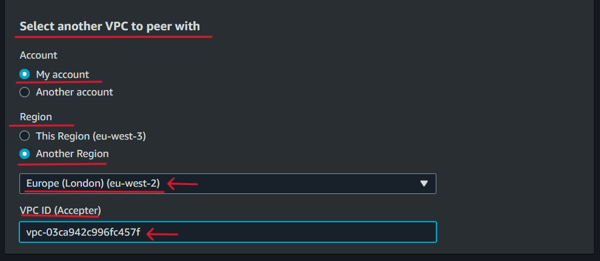

Our VPC peering connection request is created.

1. Now we need to accept the peering connection request in the London region.

* Go to the peering connection in the London region’s VPC dashboard, you will see the peering request.

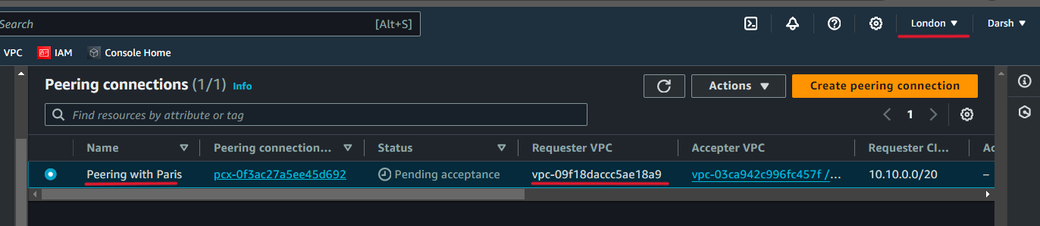

* Click on the Action button and accept it.

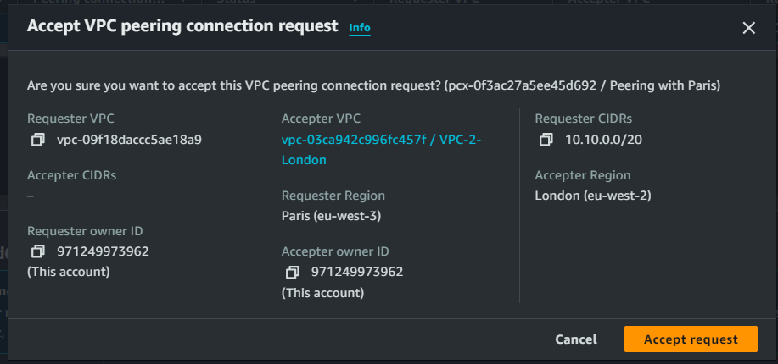

Here our peering connection created.

1. Now we need to add a route target for the VPC peering connection in the Route table of both VPCs.

* First, we will add a route in the Paris region VPC Route table.
* Copy the CIDR of the London region’s private subnet of our custom VPC.
* Edit the Route Table of the Paris region and add a new route in the destination paste the copied CIDR of the London region’s private subnet, then select the target Peering connection and save the changes.

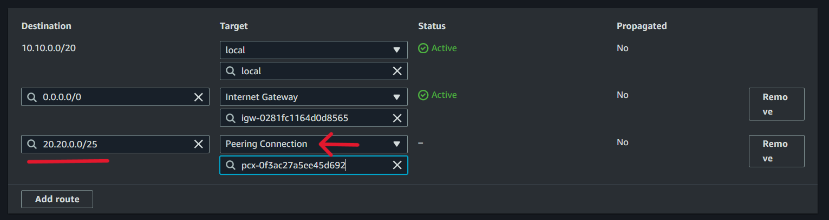

* Now as same as above step add a route in the London region’s route table of our Custom VPC.
* In the destination add the CIDR of the Paris region’s private subnet of our custom VPC.



Now our Peering connection is established. To verify whether our peering connection is correctly established or not we launch instances in both regions and check it by pinging.

1. Launching of the Instances in our custom VPCs of both regions.

* Launch all instances with the rule SSH and All TCMP IPv4 in security group.
* In Paris Region launch 1 Public instance and another Private instance.
* In the London region launch 1 private instance.
* After the instances are launched, connect the public instance of the Paris region.
* Then Get SSH of the private Instance of the Paris region by using a Bastion Host or Jump Server method.

1. Now copy the Private IP address of the Private Instance launched in the London Region and ping it by the private instance launched in the Paris region.

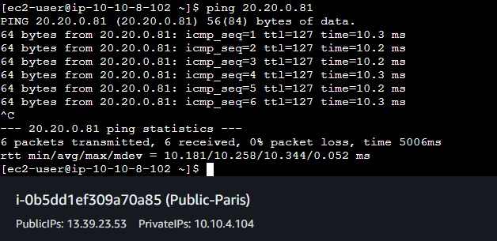

Now here we can see it is pinging, which means our peering connection is successfully established.